**“Experiment 3.1”**

Student Name: **SUMIT KUMAR** UID: **20BCS8226**

Branch: **CSE** Section/Group: **808 A**

Semester: **5** Date of Submission: **12-11-22**

Subject Name: **Multimedia Technologies Lab**  Subject Code: **20CSP-339**

**1. Aim/Overview of the practical:**

Draw a walking track on one layer. On another layer draw a stickman, with animation show the man walking over the track from left to right using Macromedia flash.

**2. Which logistics used:**

Hardware Requirements: - Minimum 384MB RAM, 100 GB hard Disk, processor with 2.1 MHz

Software Requirements: - Macromedia flash

**3. Steps for experiment/practical/Code:**

1. Open Macromedia Flash 8.
2. Create a new Flash Document.

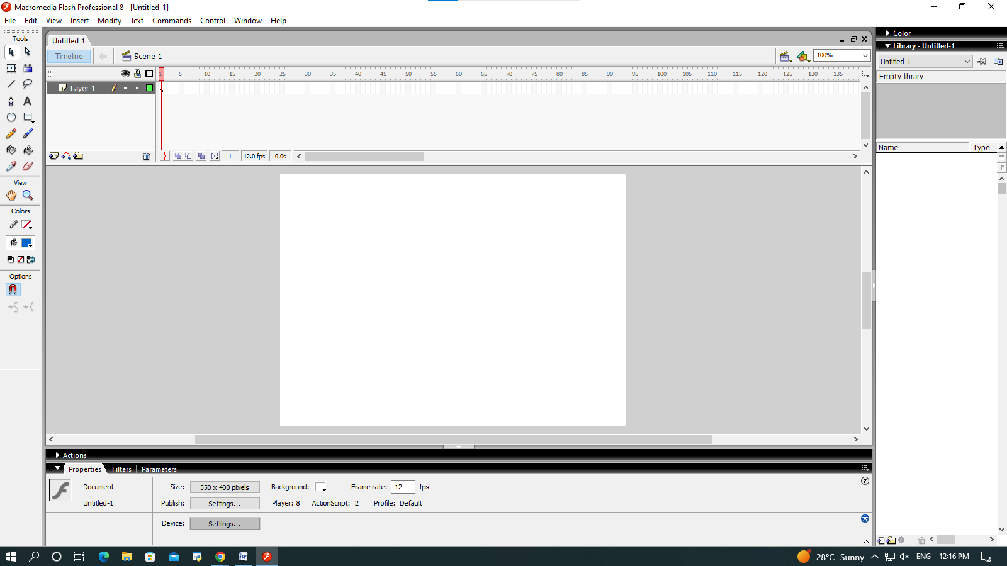

1. In the Timeline window, insert a new layer, and rename Layer 1 to Ground and Layer 2 to Stickman.

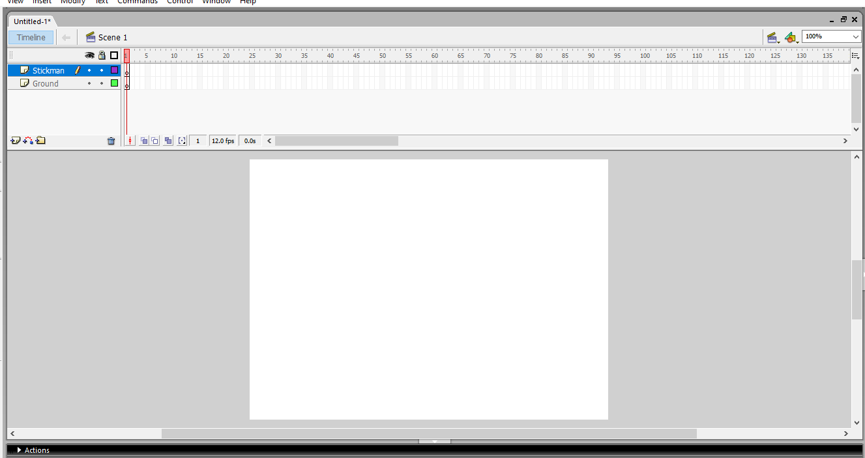

1. Select Ground layer and create a path using Rectangle Tool.

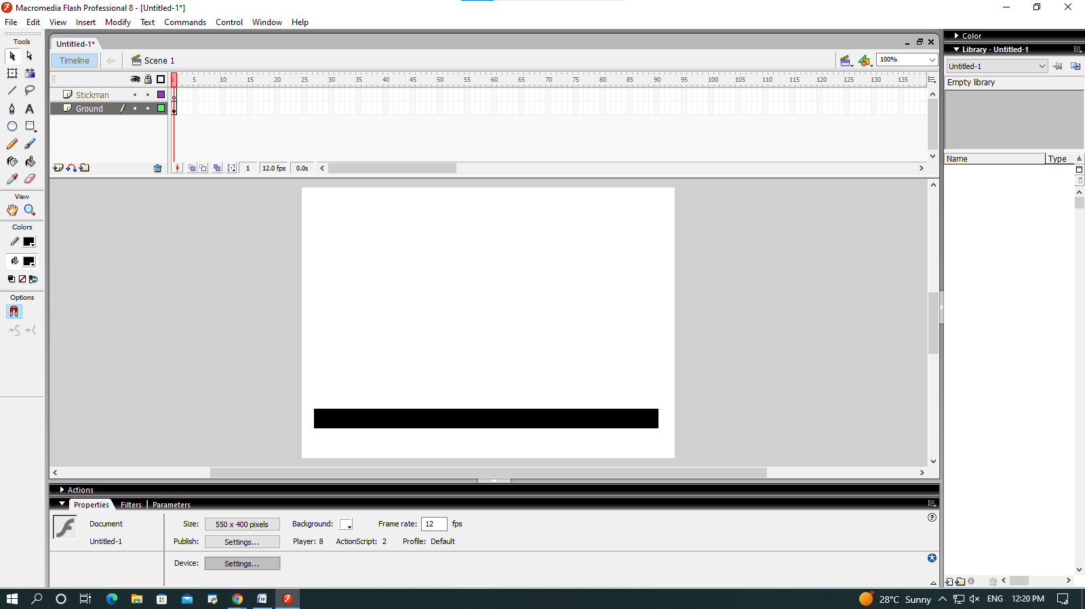

1. Use Line tool and choose line width 6 to create the body of Stickman.

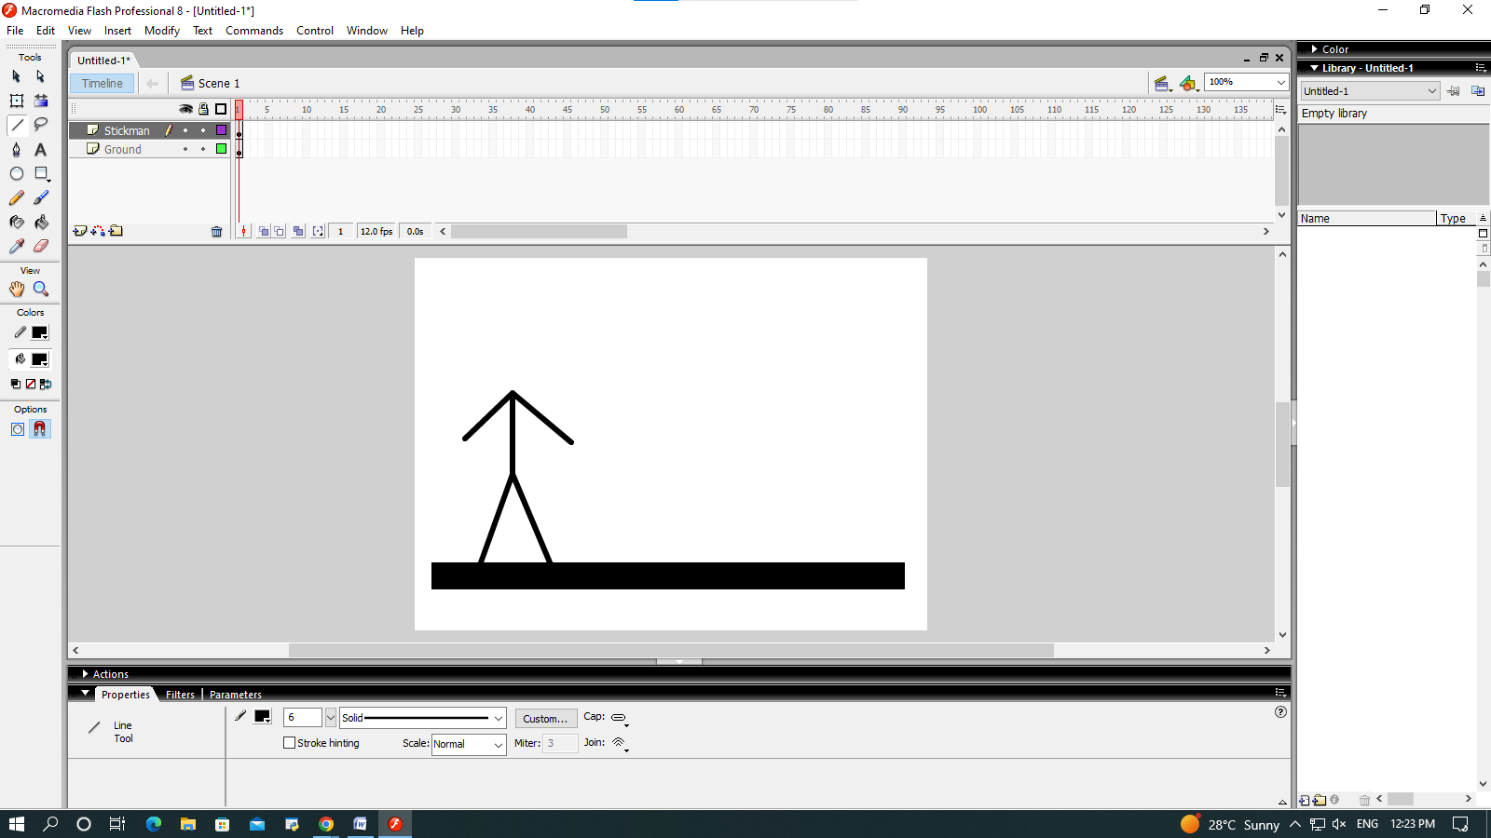

1. Use Oval tool to create the head of Stickman.

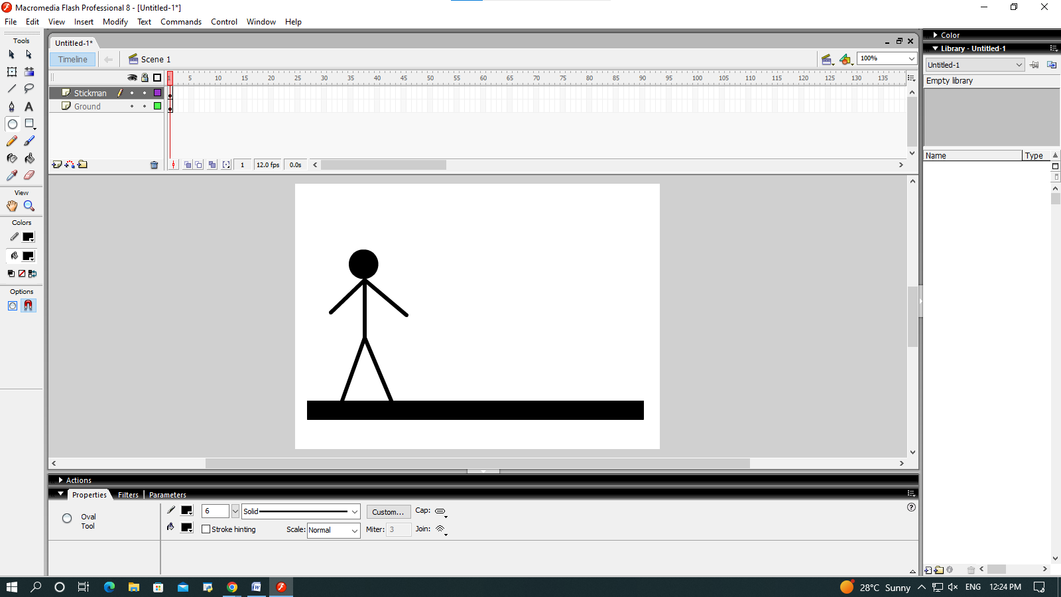

1. On the Ground Layer, Click on the dot under the eye icon to make the ground disappear, so that we can focus on Stickman for now.

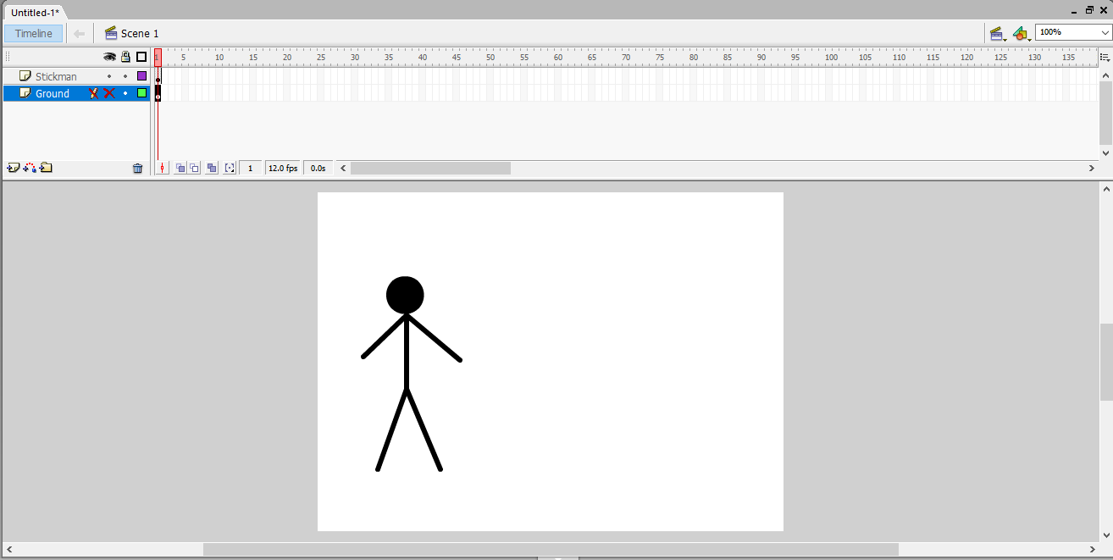

1. To convert Stickman into a Symbol, use the selection tool to select the whole Stickman and then right click and choose Convert to symbol.

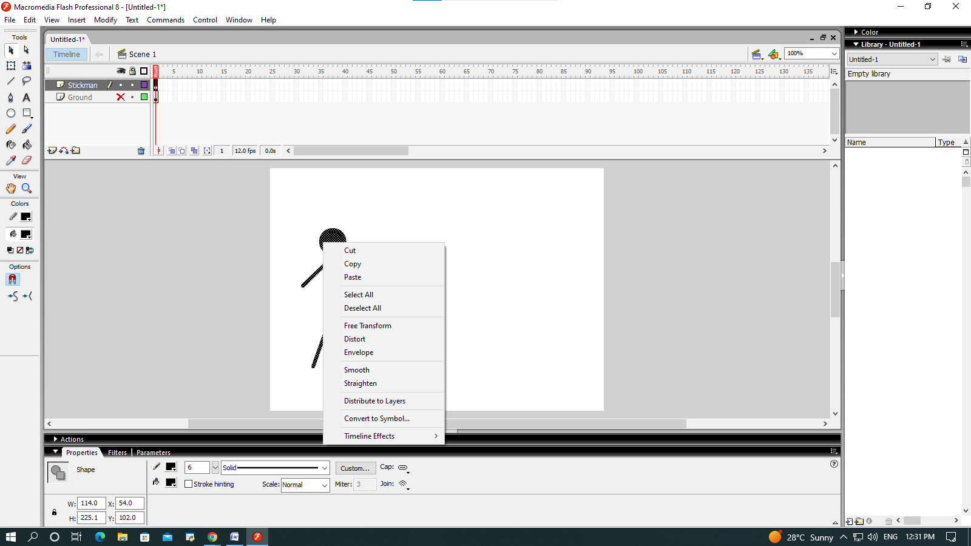

1. Now name the Stickman symbol and select the type as graphic.

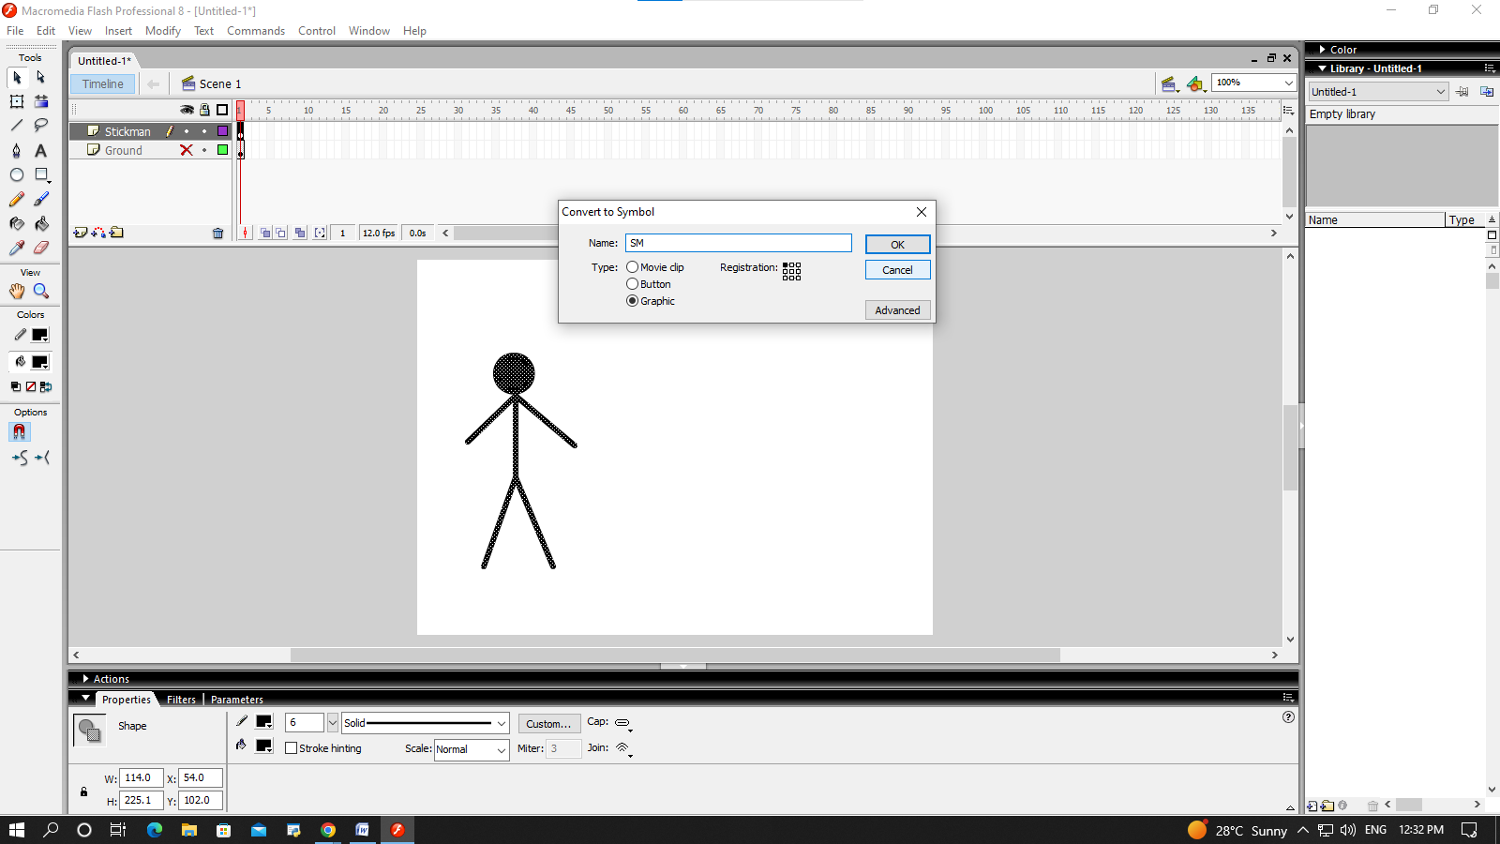

1. Double click on the stickman, then change the shape of body parts of stickman so that it looks like in walking motion.

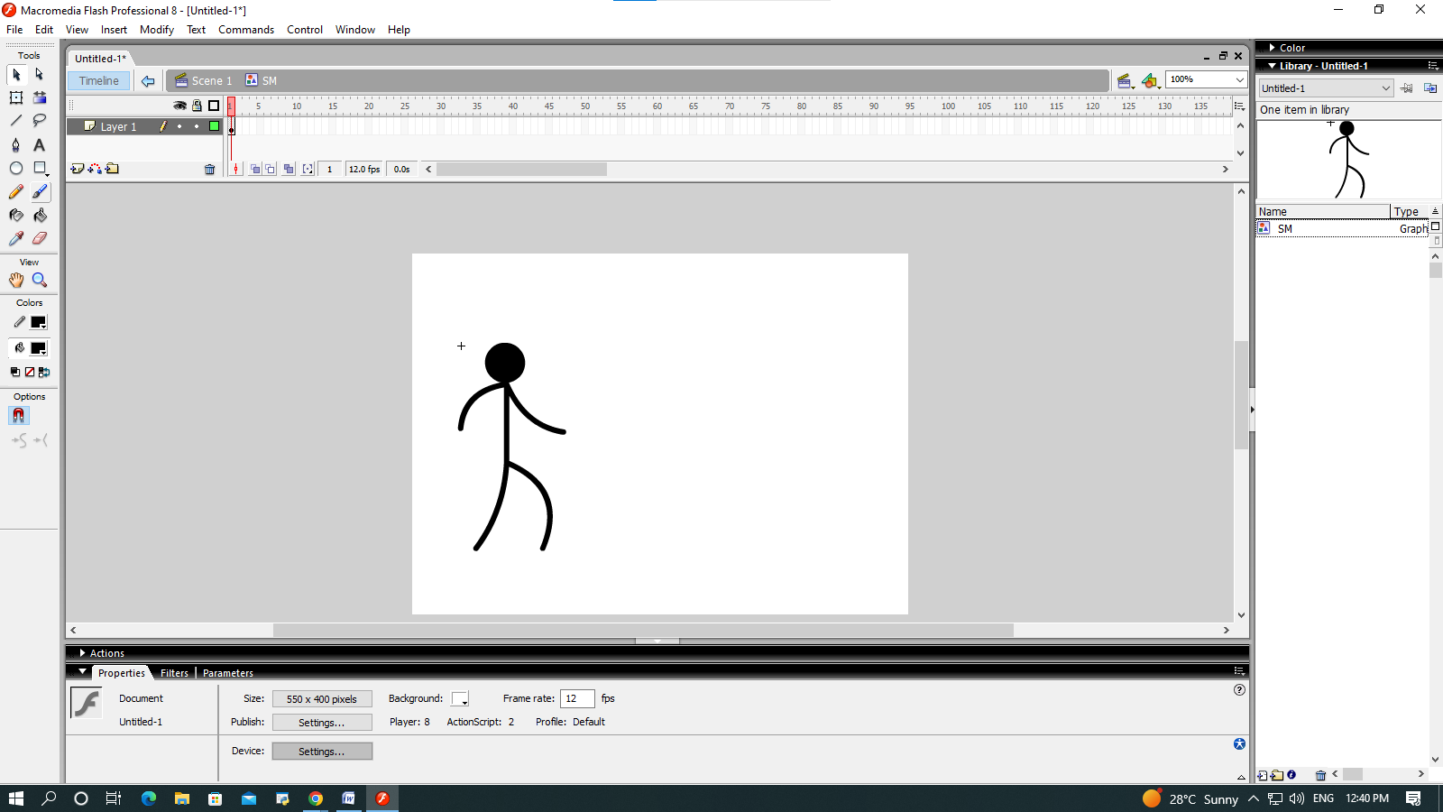

1. Now click on the number 2 in timeline and right click and select insert keyframe.

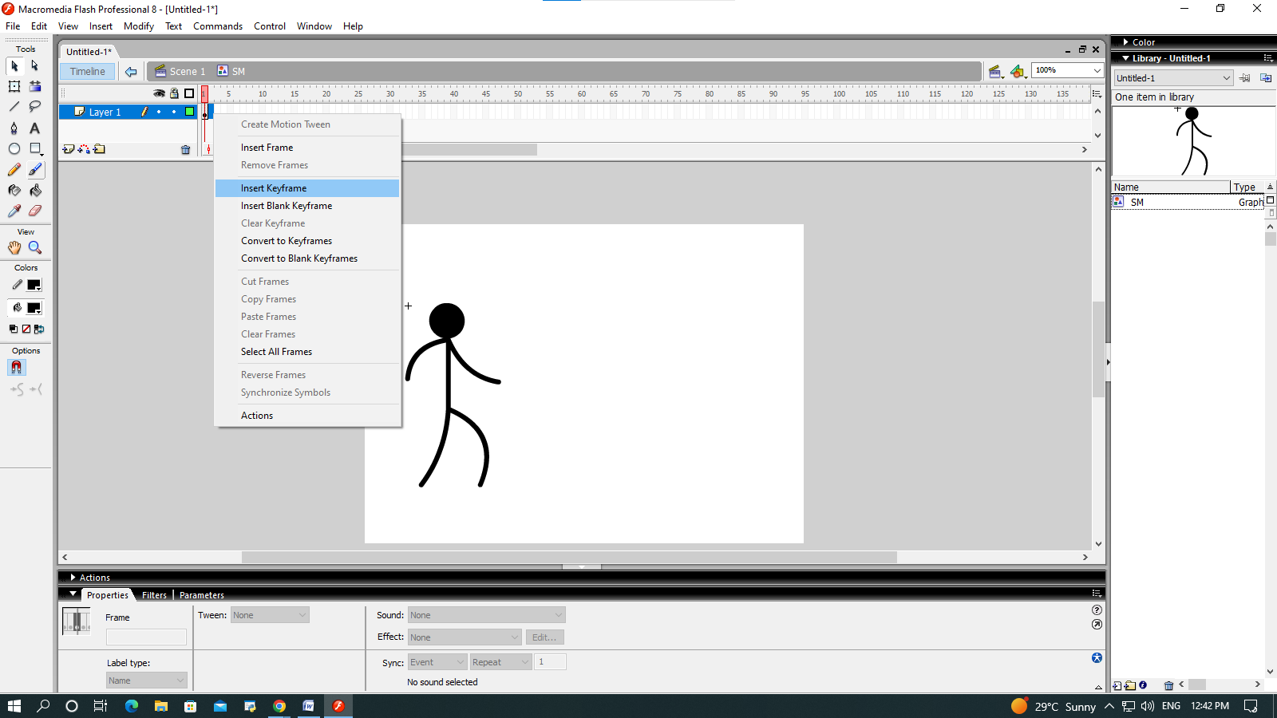

1. Do the above process again to make the stickman look like in a walking motion and insert keyframe for each motion on successive number in timeline.

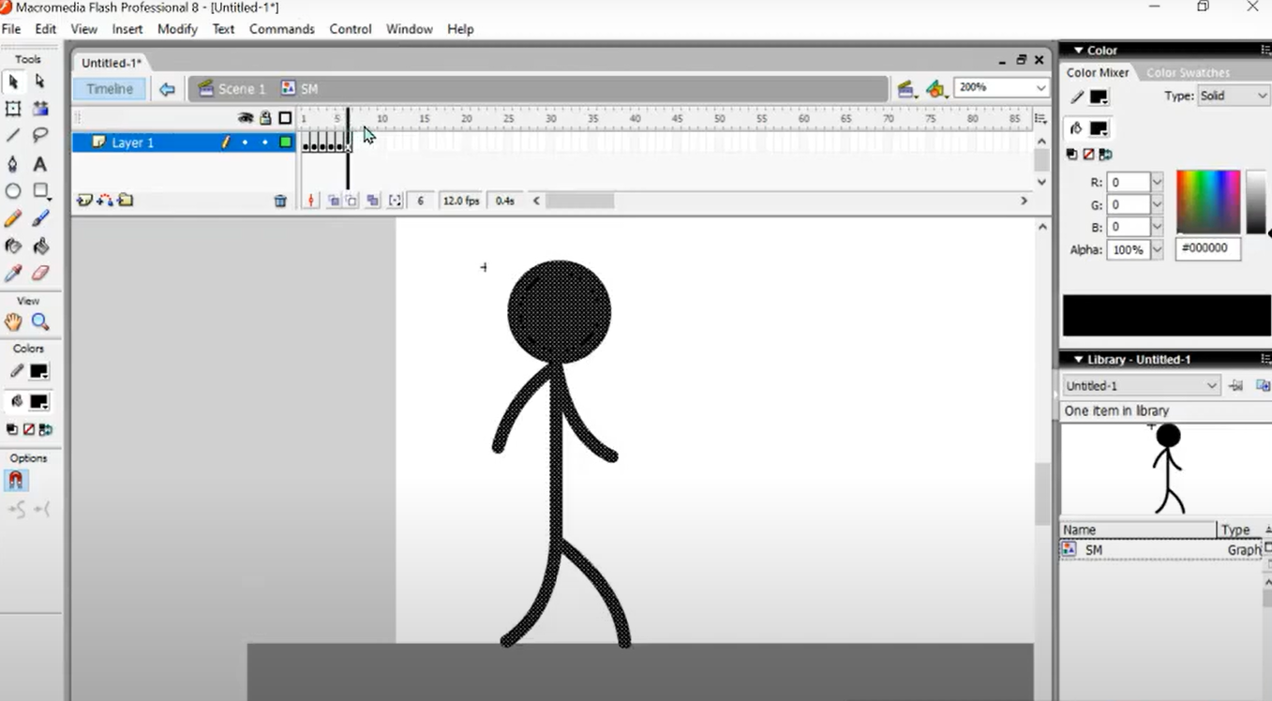

1. After that move the stickman from left to right.

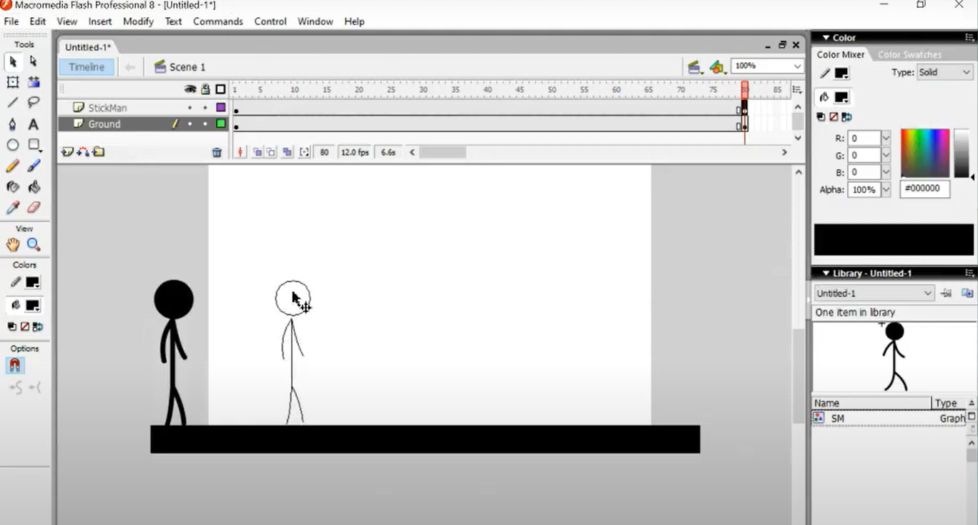

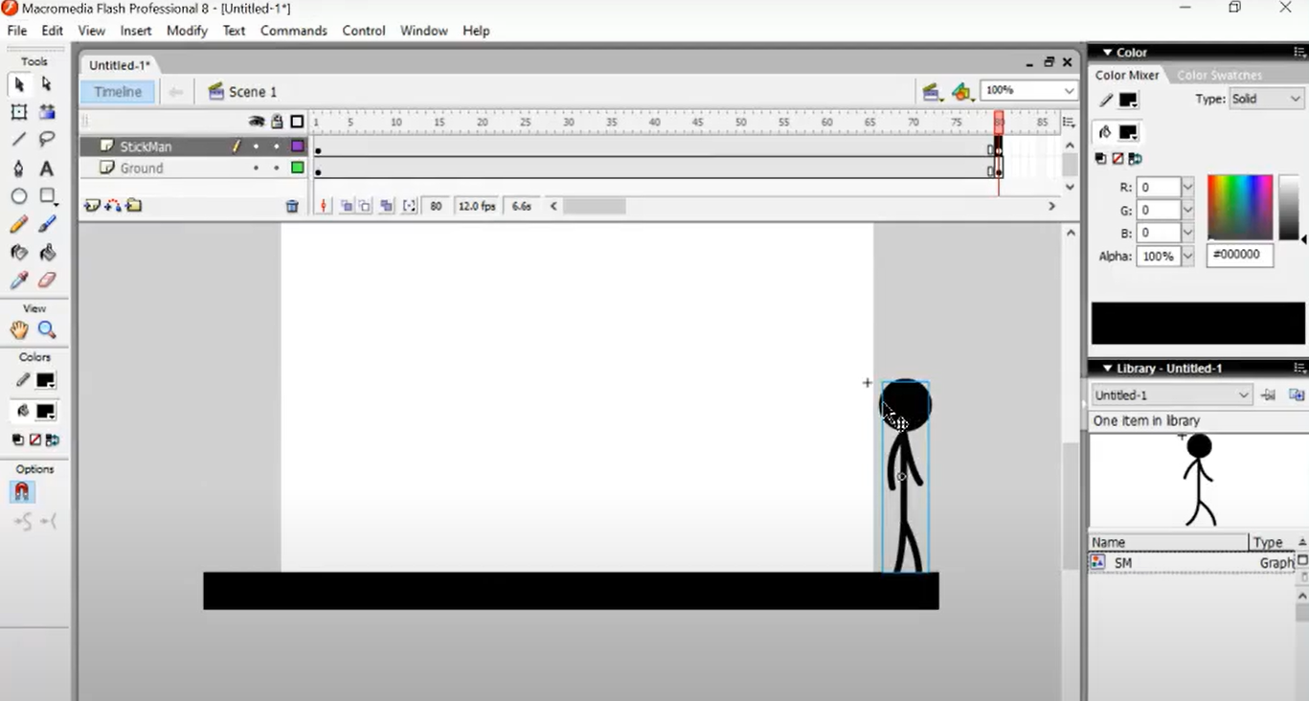

1. 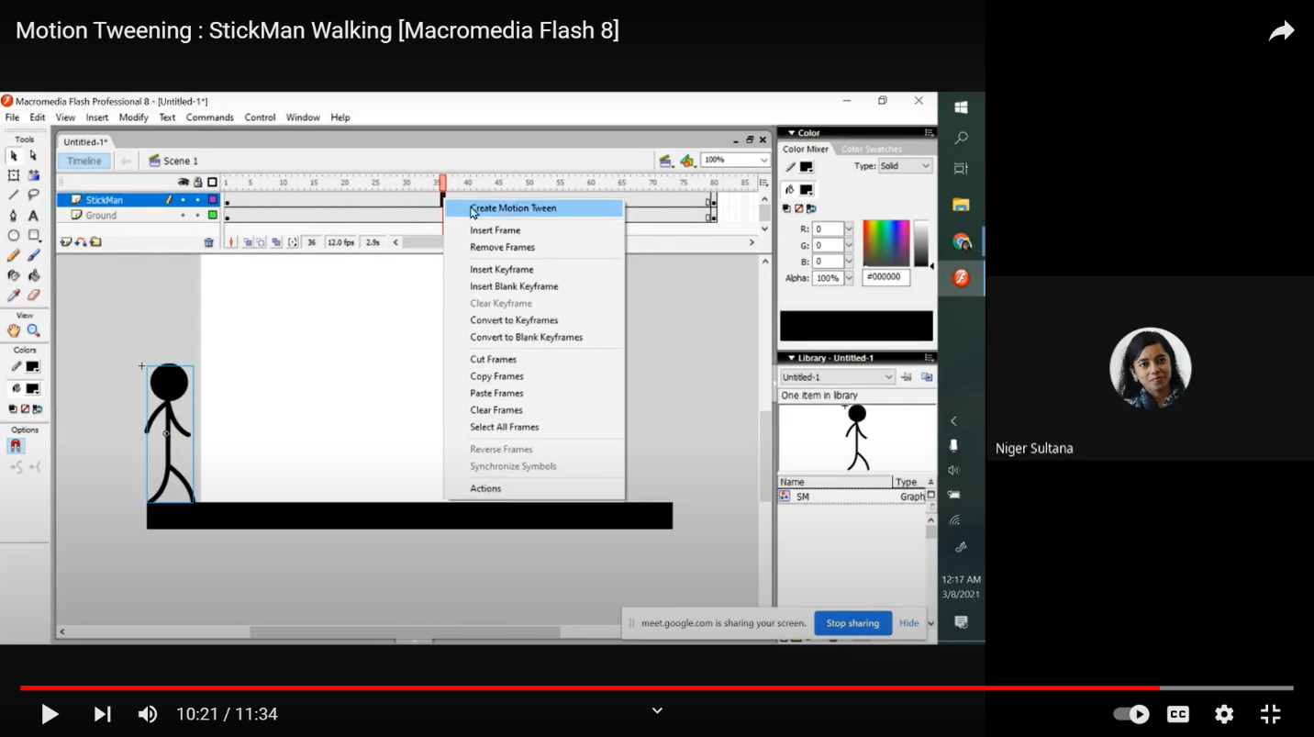After that click on create motion tween.
2. This is the final stickman which is moving from left to right.

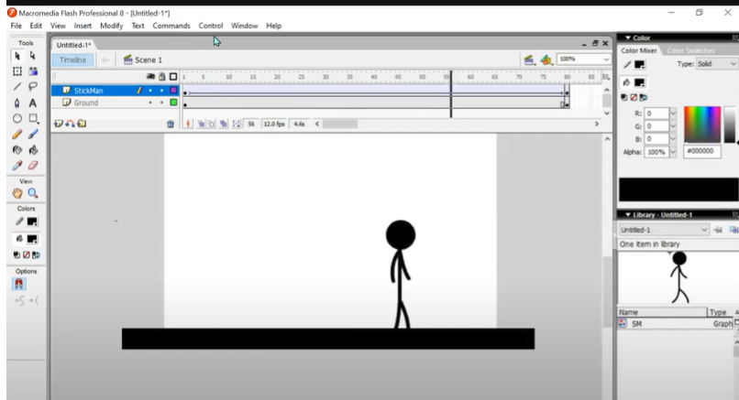

**Learning outcomes (What I have learnt):**

**1.** Learnt how to install macromedia flash.

**2.** Learnt the different features of macromedia flash.

**3.** Learnt about uses of different tools.

**4.** Learnt how to make animations using macromedia flash.

**Evaluation Grid (To be created as per the SOP and Assessment guidelines by the faculty):**

|  |  |  |  |
| --- | --- | --- | --- |
| Sr. No. | Parameters | Marks Obtained | Maximum Marks |
| 1. |  |  |  |
| 2. |  |  |  |
| 3. |  |  |  |
|  |  |  |  |